13 Classes (!not, !people)

https://colab.research.google.com/drive/1xfA_dDQQMkeiqjvTRxKp0NhQwjoIgcIl?usp=sharing
https://colab.research.google.com/drive/1F3BHHXWRuVl0LUOTu1skFO1d_BNdjdP2?usp=sharing

- MobileNetV2 - Temporal Feature Pooling instead of Prediction Averaging.
Training Accuracy: 95.92%
Validation Accuracy: 81.69%
Testing Accuracy: 80.85%
Avg time: 2.0473408699035645
Avg memory: 9.70703125

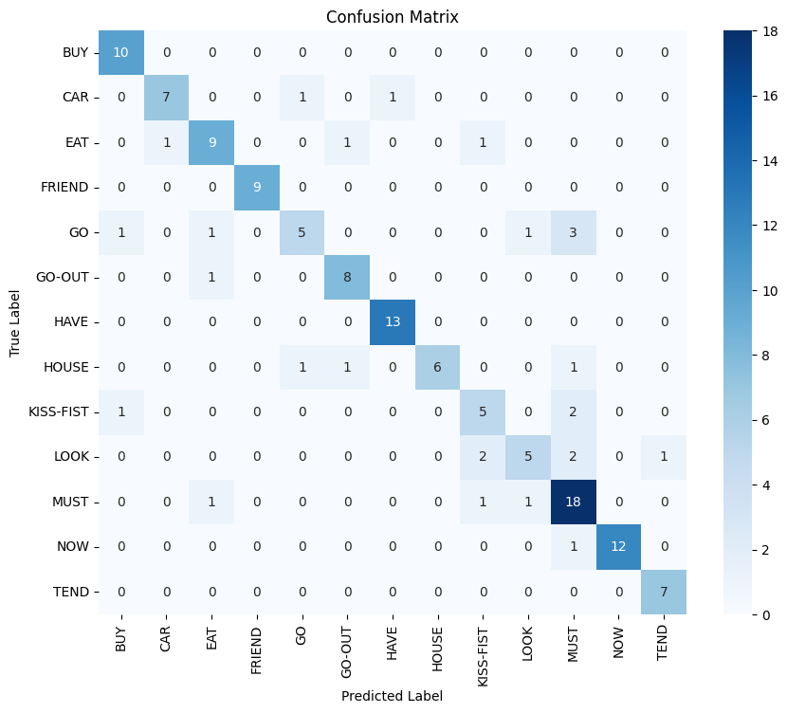
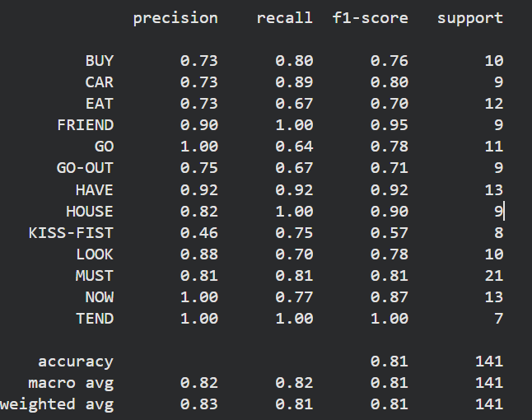

- EfficientNet
Training Accuracy: 96.33%
Validation Accuracy: 78.30%
Testing Accuracy: 73%
Avg time: 1.7010893821716309
Avg memory: 58.90234375
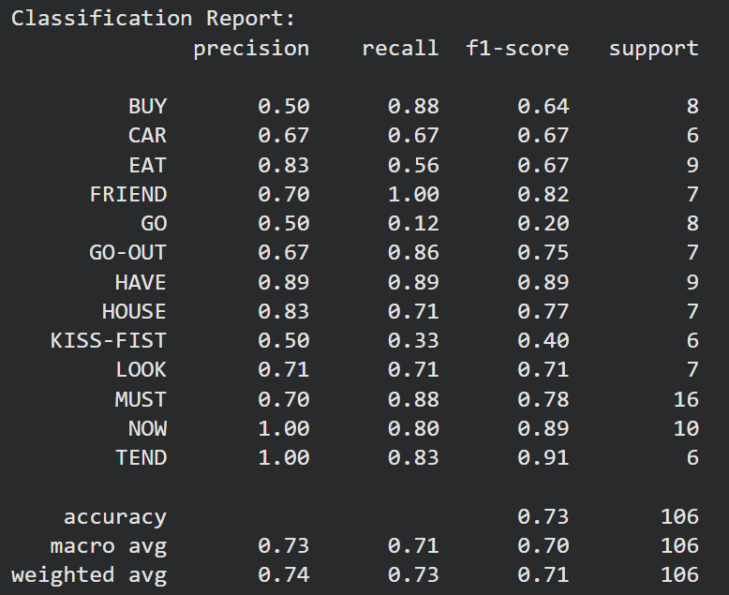
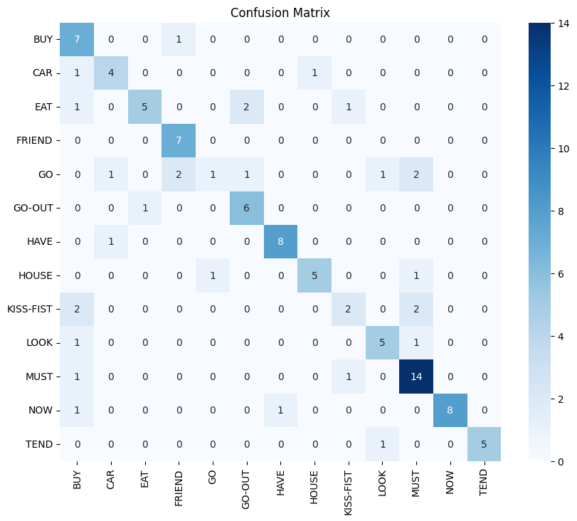

- X3D-S
Training Accuracy: 93.48%
Validation Accuracy: 71.43%
Testing Accuracy: 70.75%
Avg time: 3.4345932006835938
Avg memory: 12.125
